# Configuring Spam Protection on Eloqua

## Enable the Spam Protection in Eloqua

Navigate to the Eloqua form for which the spam protection should be enabled. Click on the gear icon and enable the Spam Protection feature

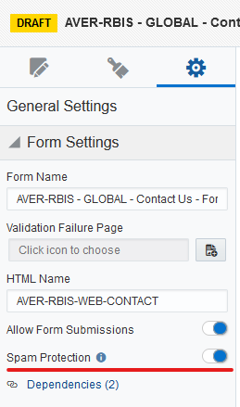

Note: Once the Spam protection feature is enabled and all the required steps are not followed properly, all the form submission will be marked as spam submissions.

## Required parameters for Spam Protection

There are 2 hidden fields to be added to enable the spam protection feature as below:

### Form Submission Token

This input tag should be added inside the <form> tag in html. This field is used to store the unique token generated in the browser through script specified in section 2. This token is used to identify whether the submission is actually from the browser or through bots.

*<input value="" type="hidden" id="elqFormSubmissionToken" name="elqFormSubmissionToken">*

### HoneyPot field

Insert a HoneyPot Field with the parent container ID as ***elq-FormLastRow***.

*<div id="elq-FormLastRow" class="row">*

*<label class="elq-label">****<HONEYPOTFIELD HTML NAME>****</label>*

*<input type="text" value="" tabindex="-1" autocomplete="off" style="width:100%;" class="elq-item-input" name="****<HONEYPOTFIELD HTML NAME>****">*

*</div>*

#### Steps to find the HoneyPot field html name

HoneyPot field will be last field in the Eloqua form with a unique HTML name. The better way to find the HoneyPot field name is through the Eloqua UI. Navigate to the Eloqua Form and click on the “Actions” and select “View Form HTML”.

In the form HTML navigate to the section where the id is “elq-FormLastRow” and find the input element inside the div. The name attribute of input is the HTML name of the HoneyPot field.

Refer the screenshot below:

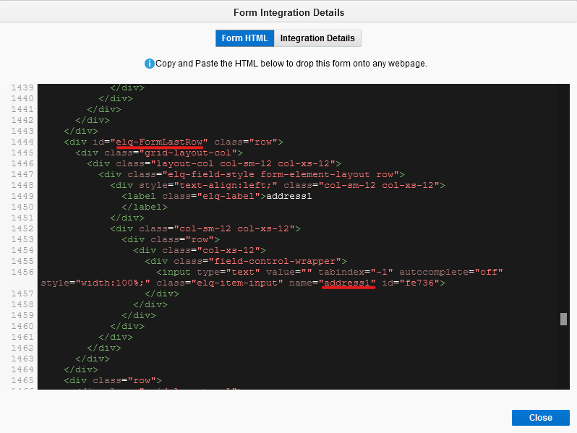

Note: Insert the Honeypot field in the external form as one of the form elements Make sure the HTML elements of the honeypot field are consistent with other fields used in the form. For example, ensure that the honeypot HTML elements contain the same amount of <div>tags.

## JavaScript to be added below the form:

### Dynamic Attributes in JavaScript

* **formId**: Provide the id attribute of the form tag available in the page, this uses to find the form and the input elements of the form.
* **siteId**: Proivide the Unique Site Id of the Eloqua Instance. The site for the Eloqua instance is '833068'

### JavaScript

*<script>*

*//Change the Form Id and site id*

*document.onload = handleDocumentLoad(*'***<formId>***', '***<siteId>****');*

*function handleDocumentLoad(b, a) {*

*window.getElqFormSubmissionToken(b, a);*

*window.processLastFormField()*

*}*

*function getElqFormSubmissionToken(g, c) {*

*var e = new XMLHttpRequest();*

*var b = document.getElementById(g);*

*if (b && b.elements.namedItem("elqFormSubmissionToken")) {*

*var f = b.action;*

*var a = window.getHostName(f);*

*a = "https://" + a + "/e/formsubmittoken?elqSiteID=" + c;*

*if (a) {*

*e.onreadystatechange = function () {*

*if (e.readyState === 4) {*

*if (e.status === 200) {*

*b.elements.namedItem("elqFormSubmissionToken").value = e.responseText*

*}*

*else {*

*b.elements.namedItem("elqFormSubmissionToken").value = ""*

*}*

*}*

*};*

*e.open("GET", a, true);*

*e.send()*

*}*

*else {*

*b.elements.namedItem("elqFormSubmissionToken").value = ""*

*}*

*}*

*}*

*function getHostName(b) {*

*if (typeof window.URL === "function") {*

*return new window.URL(b).hostname*

*}*

*else {*

*var a = b.match(/:\/\/(www[0-9]?\.)?(.[^\/:]+)/i);*

*if (a !== null && a.length > 2 && typeof a[2] === "string" && a[2].length > 0) {*

*return a[2]*

*}*

*else {*

*return null*

*}*

*}*

*}*

*//process the honey spot field*

*function processLastFormField() {*

*var form = document.getElementById("****<formId>****");*

*var lastFormField = form.querySelector("#elq-FormLastRow");*

*lastFormField.style.display = "none";*

*}*

*</script>*

## **CSS to be added to the form**

The below CSS is used to hide the HoneyPot field in the form

*<style>*

*#elq-FormLastRow {*

*position: absolute;*

*left: -80%;*

*top: -80%*

*}*

*</style>*

## **Test the Spam Protection Feature**

Submit the form and check the form submission data in Eloqua by navigating to Actions > **View Submission Data** and **View Spam Data**.

Verify the form submission data whether the data is available in **View Submission Data.**

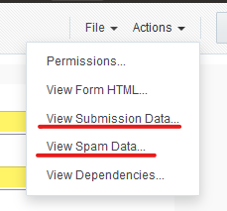

Note: Post Form Submit redirection will not work in case spam form submission.